**Error Messages for Mandatory fields – Common for all modules:**

* All the mandatory fields in the authoring interface should have an asterisk (*) next to the field label
* If the author saves the content without filling the mandatory fields, then an exclamation symbol will be shown next to the field and the field will be highlighted in red. The changes won’t be saved until these fields are filled. A message will be shown when hovered indicating that this is a mandatory field. This is the out of the box behavior in AEM.

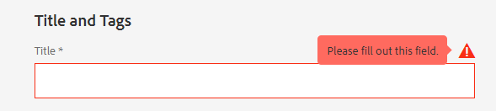

**Hero Module:**

**Main Hero Module:**

* “Background” – This field should have Color and Image as options. I don’t see video in Hero anywhere
  + If Color is selected, “Background Color” and “Font Color” fields should be shown. This should be a dropdown field with Chubb approved colors (Page 25 in Branding guidelines document)
    - Author should select Background color first. Only the Chubb approved background colors should be shown for selection
    - Once Background color is selected, then the colors that are compliant (and approved by Chubb) with the selected background color should be shown in font color dropdown for selection.
    - Separate “Styles” tab is not needed
  + If Image is selected, following fields should be shown
    - Field to select the image
    - “Is this a Decorative Image?” – check box that is checked by default
    - If the checkbox is unchecked, then a text field to enter “Image Alt Text”
    - No additional fields are needed
* “Include Search in Hero” – This is not needed in Hero as search is present in Navigation. This is not very common in hero except Find an agent page which needs a separate integration that needs to be treated separately
* “Template Variation” – I don’t see a need for this field.
  + The difference between Home and Child page are – Left border, CTA below Desc and proof points (I have an alternate solution below). It doesn’t impact to keep all these fields common for both variations as they won’t overlap each other and cause negative impact.
* “Does not have dashed list” and its line color – This field can be removed as I have an alternate solution below under text module

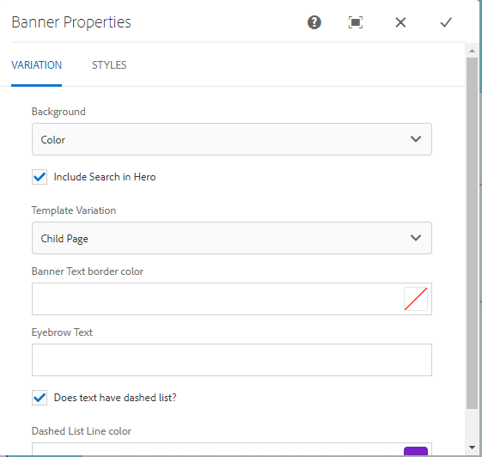

**Text Module:**

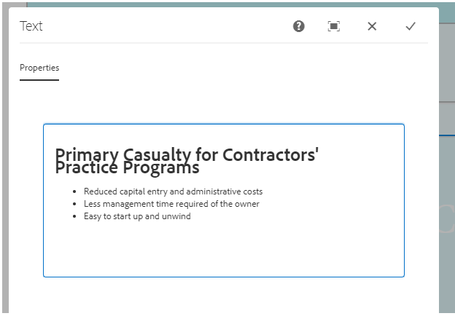

* “Title” should be a separate field
* Instead of developing separately for hyphenated points below the Title (Proof points), I suggest using an RTF field. While authoring, we can manually add “-“ before the points and add spaces between the points as needed. The output won’t match PROD exactly, but it will be closer as in <http://chubb-v2-dev.acegrpaccess.com/us-en/index-test.aspx>

**Button Module:**

Button Module is not needed between Bread crumb and Title. We have a CTA above breadcrumb in CP (<http://chubb-v2-dev.acegrpaccess.com/us-en/business-insurance/power-test.aspx>) but this is not needed.

Find the generic comments for this module. When the second button is added, there is no enough padding between the buttons

* “Text Widget button” – I don’t understand the significance of this option
* “PRS Share Button” – I don’t understand the significance of this option
* “Add Border to the Link” - I don’t understand the significance of this option
* “Button Type” should be a drop down and the options that i see valid so far is “Plain CTA” and “CTA with background”
  + “Plain CTA” – Only Label, Link, Link Target, Font Color and Arrow position fields are needed
  + “CTA with Background” - Only Label, Link, Link Target, Background color, Font Color and Arrow position fields are needed
* If any new CTA options are needed in future, then it should be added to the drop down for selection and not as a checkbox
* Data CTA and Data hp ad values shouldn’t be authored. They should be automatically generated as per the guidelines
* Fields should be added in logical order like Button type selection, Label, Link …

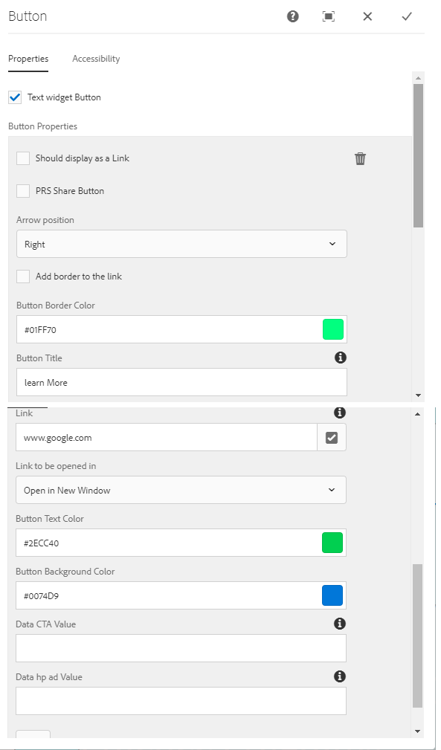

**Floating Button in the bottom Right:**

* Similar comments as given in Button component
* For Floating ribbon, add option shouldn’t be there as it adds to the right of the current button
* In CP, we can add 2 floating buttons one below the other. So that needs to be enabled in this